Question 1
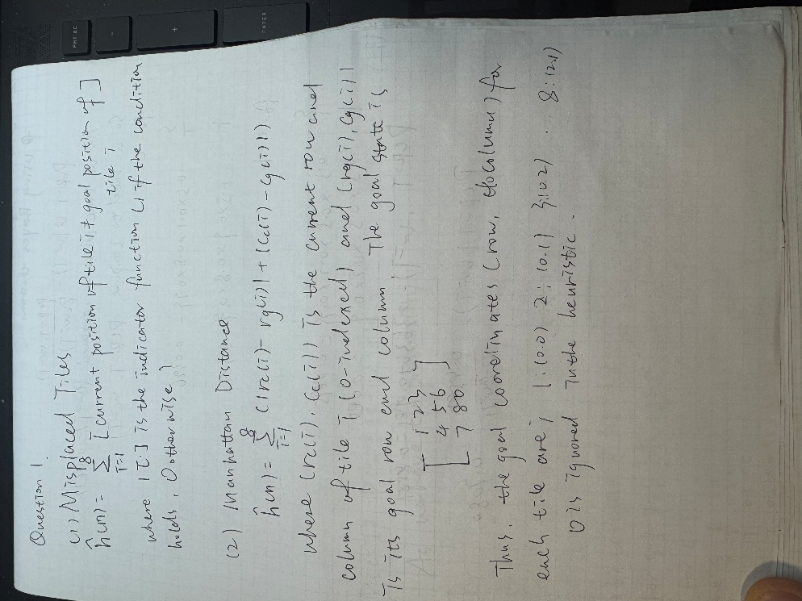
Question 2 :Output of the code
